**Textbook Program**

# Author = Darren Isaacson

# This program is designed to calculate the total cost of books purchased

# While loop variant

books = int(input("How many textbooks? "))

total = 0.0

bookCount = 1

while bookCount <= books : # test the condition

price = float(input("Enter price of book %d: " % bookCount))

total = total + price

bookCount = bookCount + 1 # add 1 to the bookCount

print("All the books cost $%6.2f" % total)

# For loop variant

books = int(input("How many textbooks did you buy this semester?"))

moneySpent = 0.0

for number in range(books): # "5" will not be included, it will reach "4"

bookPrice = float(input("Type a textbook price: " + str(number + 1)))

moneySpent = moneySpent + bookPrice

# Formmated with condition shorcuts

print("Total spend = $%0.2f" % moneySpent)

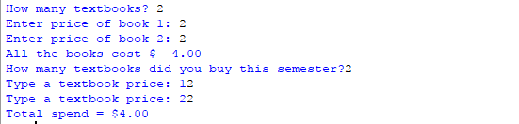

# Author = Darren Isaacson

# This program is designed to create loop variation to how what i learned

# Loop which prints all of the numbers between 0 and 5.

print("This output is going to be 0-5")

for loop in range(6):

print(loop)

nextLoop = input("\nEnter to continue to next loop")

# Loop which prints all of the numbers between 1 and 20.

print("\nThis output is going to be 1-20")

for loop in range(20):

print(loop+1)

nextLoop = input("\nEnter to continue to next loop")

# Loop which prints all of the even numbers between 0 and 25.

print("\nThis output is display the even numbers from 0-25")

for loop in range(0,25,2):

print(loop)

nextLoop = input("\nEnter to continue to next loop")

# Loop which prints all of the odd numbers between 37 and 53.

print("\nThis output is display the odd numbers from 37-53")

for loop in range(37,54,2):

print(loop)

nextLoop = input("\nEnter to continue to next loop")

# Loop which prints 10, 20, 30, 40, 50, 60.

print("\nThis output is display the multiples of 10 from 10-60")

for loop in range(10,61,10):

print(loop)

nextLoop = input("\nEnter to continue to next loop")

# Loop which prints the numbers between 30 and 20, counting down.

print("\nThis output is display the counts down from 30 to 20")

for loop in range(30,19, -1):

print(loop)

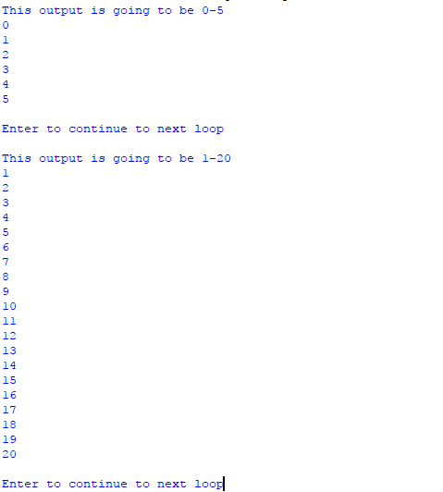

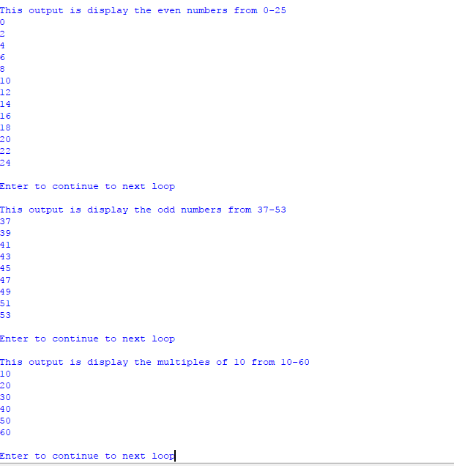

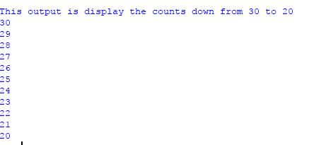

**Loop-2**

# Author = Darren Isaacson

# This program is designed to accumulate the users numbers chosen

# Users input for base and upper values

baseNumber = int(input("What is your base number? :"))

upperNumber = int(input("What is your upper number? :"))

# Total baseline for accumulator

total = 0

# For loop variant

for number in range(baseNumber, upperNumber + 1):

print(number) # prints the accumlation

total = total + number

# prints total

print("The total amount is : %d" % total)

